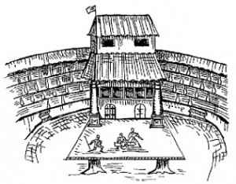

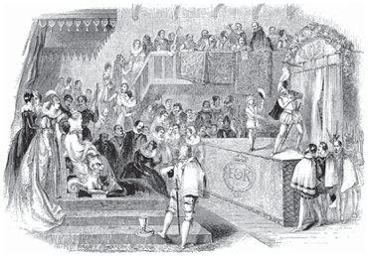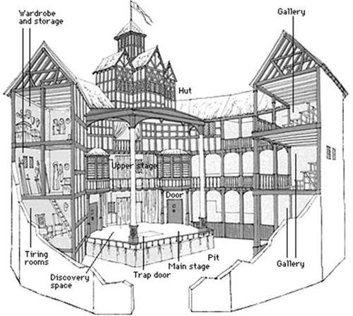

|  |  |
| --- | --- |
| http://art.1september.ru/2009/04/12-1.jpg | http://literatura5.narod.ru/shakespeare_globus_p.JPG |

|  |  |
| --- | --- |
| &Rcy;&IEcy;&Vcy;&IEcy;&Rcy;&Scy;: &Ncy;&acy;&scy;&tcy;&ocy;&lcy;&softcy;&ncy;&acy;&yacy; &mcy;&iecy;&dcy;&acy;&lcy;&softcy; «400 &lcy;&iecy;&tcy; &scy;&ocy; &dcy;&ncy;&yacy; &rcy;&ocy;&zhcy;&dcy;&iecy;&ncy;&icy;&yacy; &Vcy;&icy;&lcy;&softcy;&yacy;&mcy;&acy; &SHcy;&iecy;&kcy;&scy;&pcy;&icy;&rcy;&acy;» &numero; 2854&acy; | &Acy;&Vcy;&IEcy;&Rcy;&Scy;: &Ncy;&acy;&scy;&tcy;&ocy;&lcy;&softcy;&ncy;&acy;&yacy; &mcy;&iecy;&dcy;&acy;&lcy;&softcy; «400 &lcy;&iecy;&tcy; &scy;&ocy; &dcy;&ncy;&yacy; &rcy;&ocy;&zhcy;&dcy;&iecy;&ncy;&icy;&yacy; &Vcy;&icy;&lcy;&softcy;&yacy;&mcy;&acy; &SHcy;&iecy;&kcy;&scy;&pcy;&icy;&rcy;&acy;» &numero; 2854&acy; |

